|  |
| --- |
| Computer Programming; |
| Assignment # 3; |
| Name: S.M Zain-ul-abideen |
|  |
| **ID:9625** |
|  |

|  |
| --- |
|  |

Program#1:

A program that will be taking 2 integer values as tens and will have two static values display the values in the following format.

|  |
| --- |
|  |

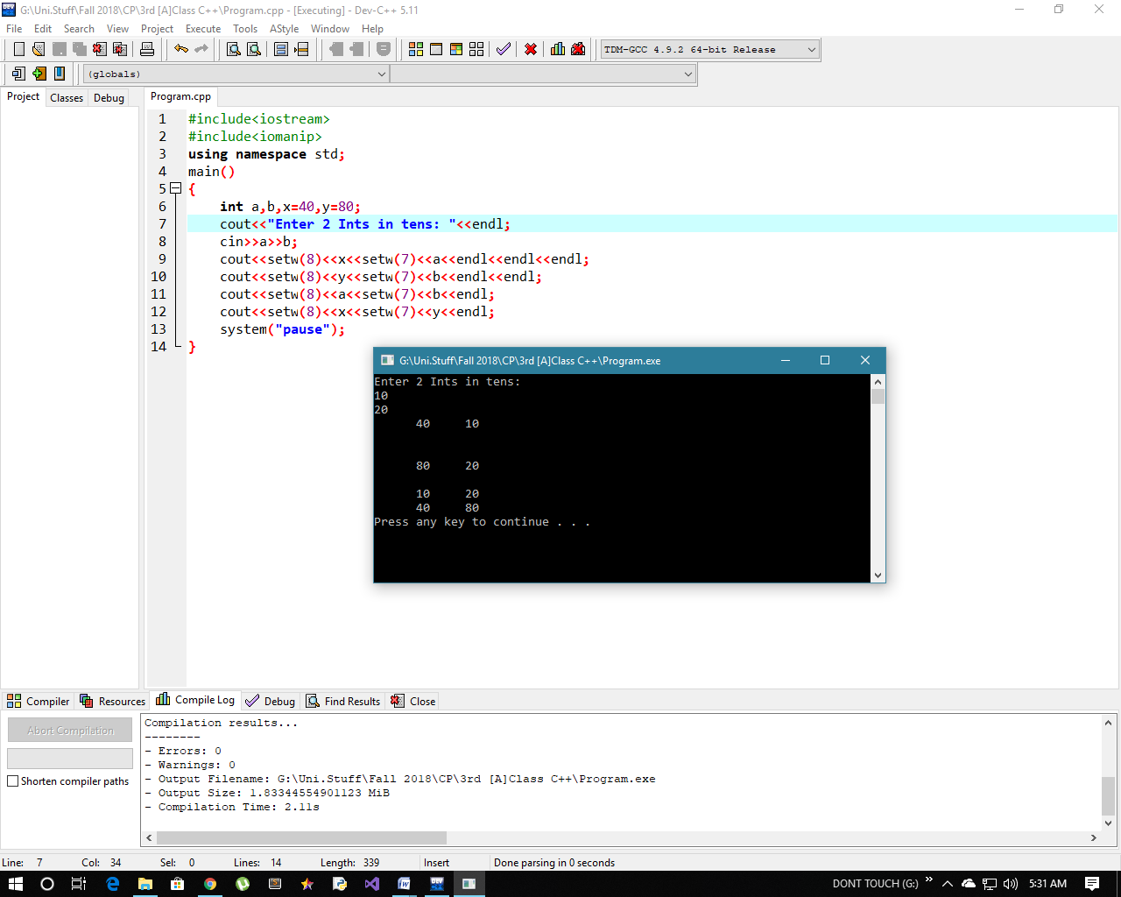

If condition-4:

A program that will be taking two int values as input and will be computing their product check if the value of product is greater than **150** compute and display half of it along with the actual value of product otherwise calculate and display double of product along with the actual value of product.

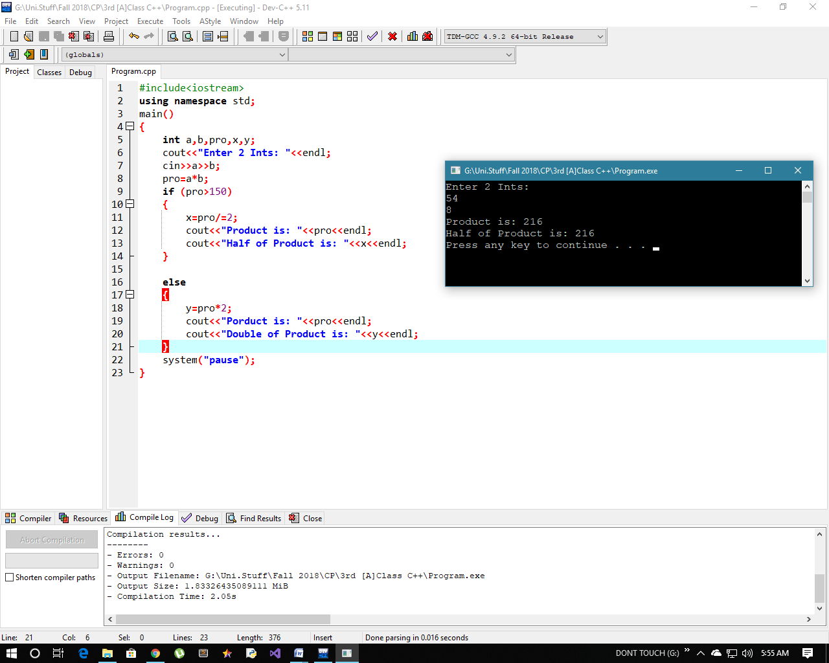

If condition-3:

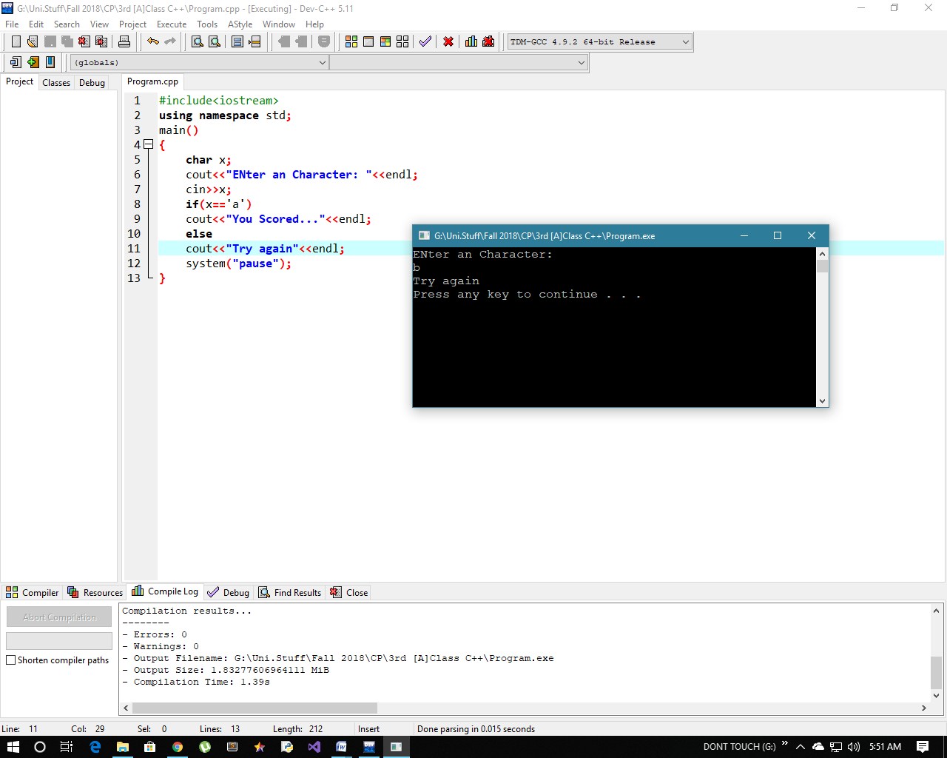A program that will be taking a char as input and will check if it is equal to ‘a’ display **“you scored”** otherwise display **“try again”**.

**If condition-2:**

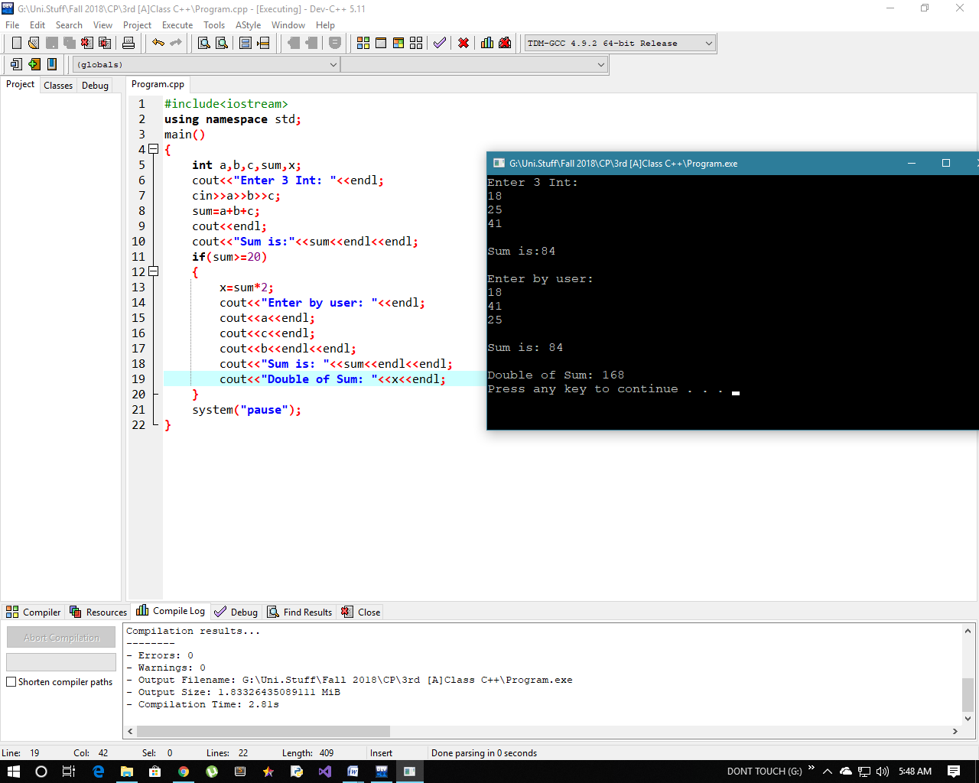A program that will be taking 3 int values as input from the user and calculate their sum. Check if the value of sum is greater than or equals to **20**. Calculate double of sum and display values enter by the user, value of sum and value of double of sum.

If condition-1:

A program that will be taking 2 int values as input from the user and compute their product, check if the value of product is greater than 50 display the same.

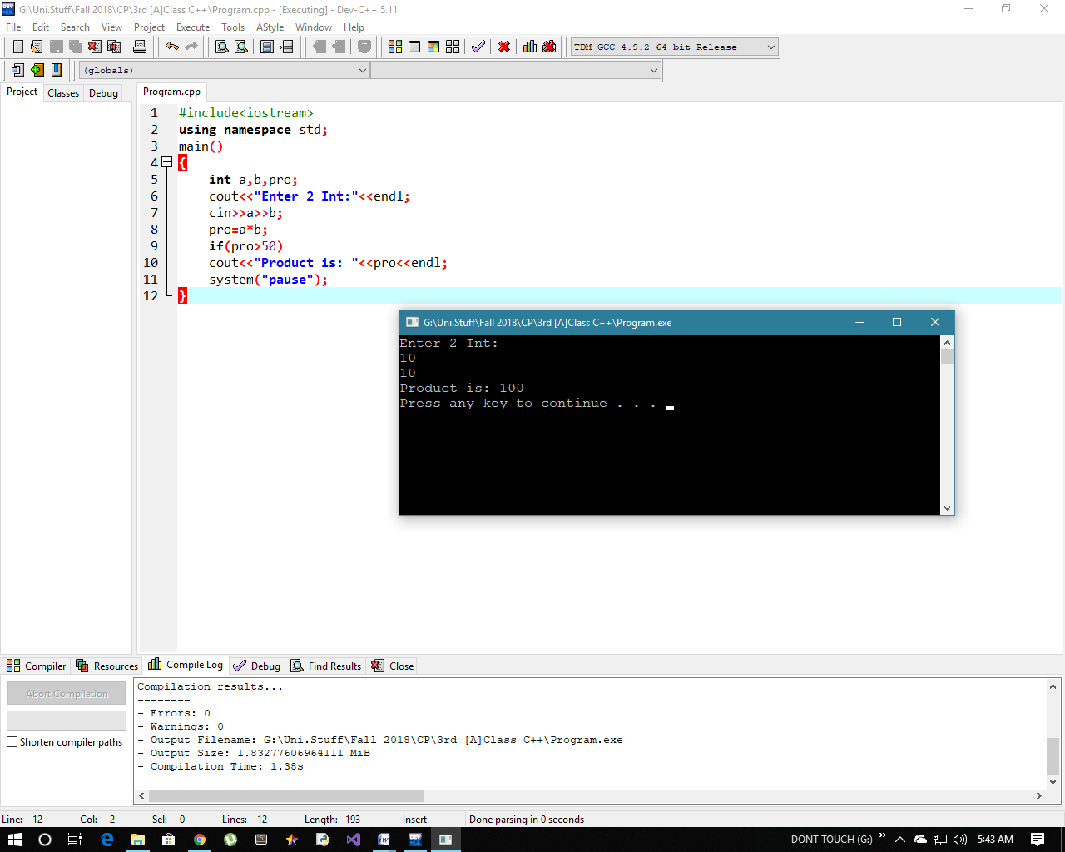

Program # 2:

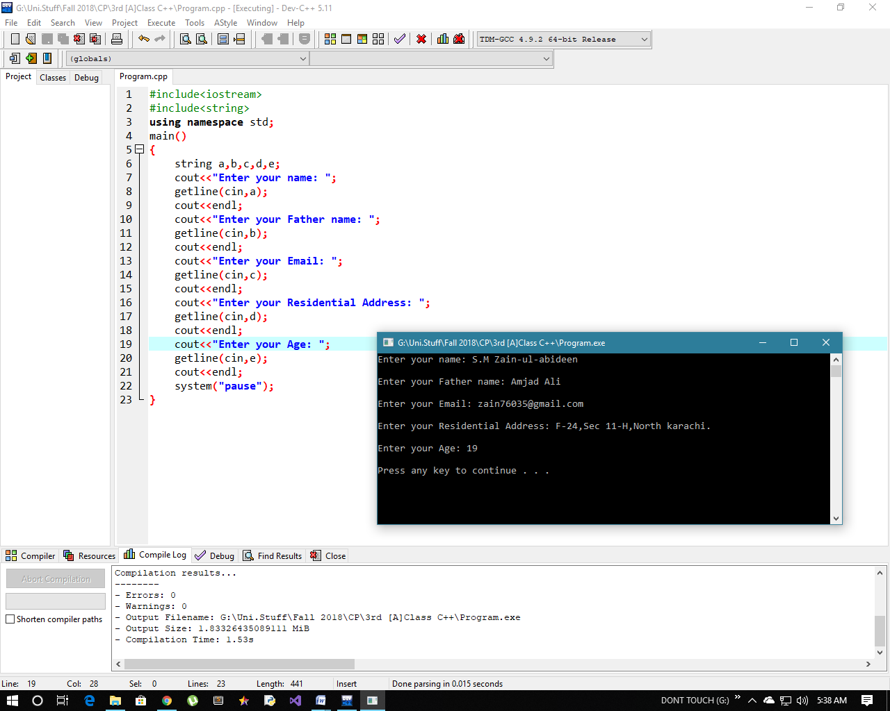A program that will be asking the user to enter his profile including name, father name, email address, residential address, age and will be displaying in the format.